## Task 01: Create Packages for Reload Dimension from SA_*

Create Packages to reload Dim data

* + Use Explicit Cursor (One package)

CREATE OR REPLACE PACKAGE BODY pkg_etl_dim_customers_dw

AS

*-- Load Data From Sources table to DataBase*

PROCEDURE load_tmp_customers

AS

CURSOR c_fg

IS

( SELECT DISTINCT sa_t.cust_first_name

, t2.geo_id

, sa_t.cust_last_name

, sa_t.cust_gender

, sa_t.cust_birth_year

, sa_t.cust_email

, sa_t.cust_pass_number

, sa_t.cust_balance

, sa_t.cust_level_income

, t3.cust_pass_number AS code

, t3.cust_balance AS bal

, t3.cust_level_income AS lev

FROM u_sa_data.tmp_customers sa_t

LEFT OUTER JOIN u_dw_references.cu_countries t2

ON ( sa_t.cust_country_desc = t2.region_desc )

LEFT JOIN u_dw.dw_customers t3

ON ( sa_t.cust_pass_number = t3.cust_pass_number ) );

BEGIN

DELETE FROM u_dw.dw_customers dw_t

WHERE dw_t.cust_pass_number NOT IN (SELECT DISTINCT cust_pass_number

FROM u_sa_data.tmp_customers);

*--Insert Source data*

FOR i IN c_fg LOOP

IF i.cust_pass_number = i.code THEN

UPDATE u_dw.dw_customers dw_c

SET dw_c.cust_balance = i.cust_balance

, dw_c.cust_level_income = i.cust_level_income

, dw_c.update_dt = SYSDATE

WHERE i.cust_pass_number = i.code

AND ( i.cust_balance != i.bal

OR i.cust_level_income != i.lev );

ELSIF i.cust_pass_number != NVL ( i.code, -99 ) THEN

INSERT INTO u_dw.dw_customers ( cust_id

, cust_geo_id

, cust_first_name

, cust_last_name

, cust_gender

, cust_year_of_birth

, cust_email

, cust_pass_number

, cust_balance

, cust_level_income

, insert_dt )

VALUES ( seq_customers.NEXTVAL

, i.geo_id

, i.cust_first_name

, i.cust_last_name

, i.cust_gender

, i.cust_birth_year

, i.cust_email

, i.cust_pass_number

, i.cust_balance

, i.cust_level_income

, SYSDATE );

END IF;

END LOOP;

COMMIT;

END load_tmp_customers;

END pkg_etl_dim_customers_dw;

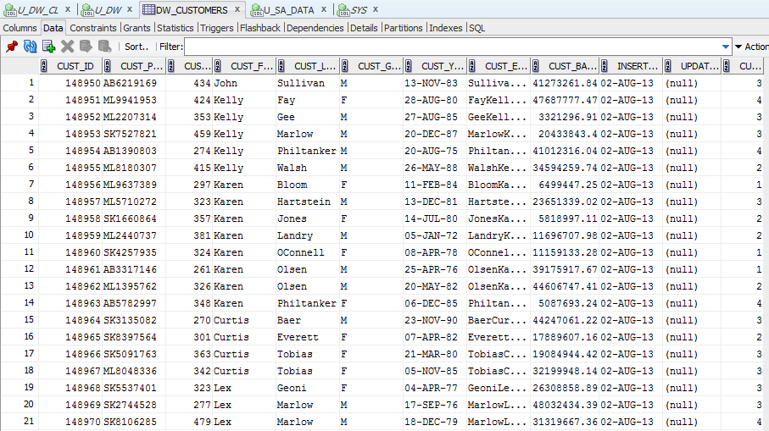

After updating the data in the source table and restart the package data is changed at stage-level.

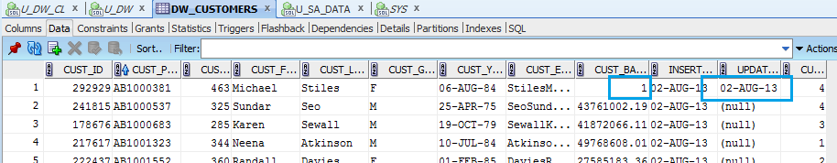

After repeated run the package the data in the table are unchanged. Test results are shown below:

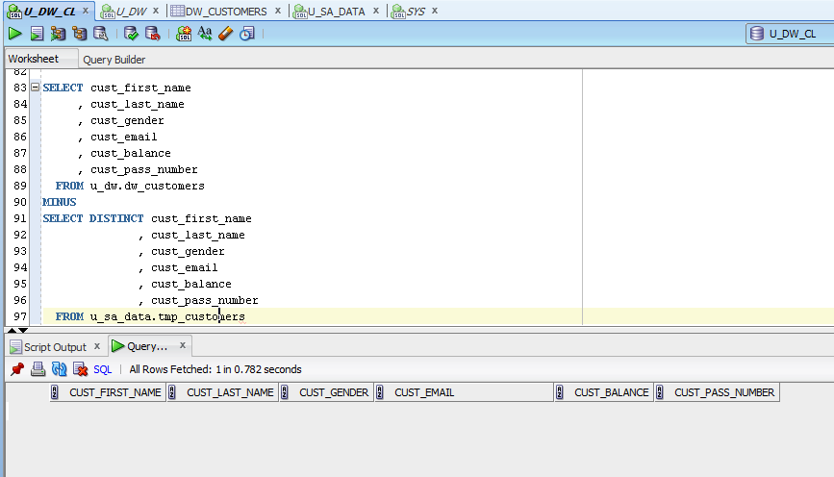

* + Use Merge (One packages)

CREATE OR REPLACE PACKAGE BODY pkg_etl_dim_operations_dw

AS

*-- Reload Data From Sources table to DataBase*

PROCEDURE load_tmp_methods

AS

BEGIN

*--Merge Source data*

MERGE INTO u_dw.dw_operation_methods o_m

USING (SELECT DISTINCT operation_method_id

, operation_method_name

, operation_method_type

, operation_method_type_id

FROM u_sa_data.tmp_methods) cls

ON ( o_m.operation_method_code = cls.operation_method_id )

WHEN NOT MATCHED THEN

INSERT ( o_m.operation_method_id

, o_m.operation_method_code

, o_m.operation_method_name

, o_m.operation_method_type

, o_m.operation_method_type_id

, o_m.insert_dt )

VALUES ( seq_operation_methods.NEXTVAL

, cls.operation_method_id

, cls.operation_method_name

, cls.operation_method_type

, cls.operation_method_type_id

, SYSDATE )

WHEN MATCHED THEN

UPDATE SET o_m.operation_method_name = cls.operation_method_name

, o_m.operation_method_type = cls.operation_method_type

, o_m.operation_method_type_id = cls.operation_method_type_id

, o_m.update_dt = SYSDATE

WHERE o_m.operation_method_type != cls.operation_method_type

OR o_m.operation_method_type_id != cls.operation_method_type_id

OR o_m.operation_method_name != cls.operation_method_name;

*--Commit Result*

COMMIT;

END load_tmp_methods;

PROCEDURE load_tmp_operations

AS

BEGIN

*--Merge Source data*

MERGE INTO u_dw.dw_operations o_s

USING (SELECT DISTINCT operation_id

, operation_name

, operation_max_amount

, operation_min_amount

FROM u_sa_data.tmp_operations) cls

ON ( o_s.operation_code = cls.operation_id )

WHEN NOT MATCHED THEN

INSERT ( operation_id

, operation_code

, operation_name

, operation_max_amount

, operation_min_amount

, insert_dt )

VALUES ( seq_operations.NEXTVAL

, cls.operation_id

, cls.operation_name

, cls.operation_max_amount

, cls.operation_min_amount

, SYSDATE )

WHEN MATCHED THEN

UPDATE SET o_s.operation_name = cls.operation_name

, o_s.operation_max_amount = cls.operation_max_amount

, o_s.operation_min_amount = cls.operation_min_amount

, o_s.update_dt = SYSDATE

WHERE o_s.operation_name != cls.operation_name

OR o_s.operation_max_amount != cls.operation_max_amount

OR o_s.operation_min_amount != cls.operation_min_amount

;

*--Commit Result*

COMMIT;

END load_tmp_operations;

END pkg_etl_dim_operations_dw;

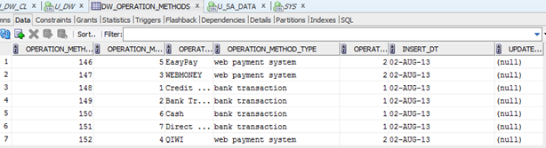

After updating the data in the source table and restart the package data is changed at stage-level.

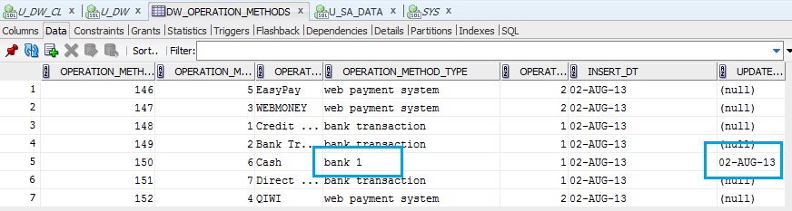

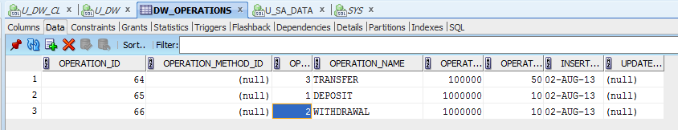

After repeated run the package the data in the table are unchanged. Test results are shown below:

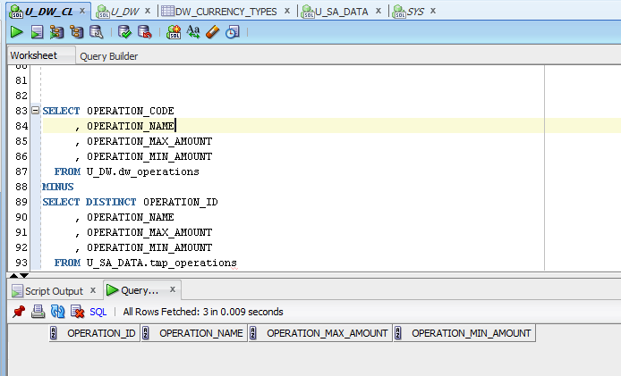

* + Use Explicit Cursor and Bulk Insertion

CREATE OR REPLACE PACKAGE BODY pkg_etl_currency_dw

AS

*-- Reload Data From Sources table to DataBase*

PROCEDURE load_currency_types

AS

CURSOR c1

IS

SELECT DISTINCT sa_t.currency_type_id

, sa_t.currency_type_name

, dw_t.currency_type_desc

, dw_t.currency_type_code

FROM u_sa_data.tmp_currency sa_t

LEFT JOIN

u_dw.dw_currency_types dw_t

ON ( dw_t.currency_type_code = sa_t.currency_type_id );

TYPE cur_type IS TABLE OF c1%ROWTYPE;

curr cur_type;

BEGIN

OPEN c1;

FETCH c1

BULK COLLECT INTO curr;

FOR i IN curr.FIRST .. curr.LAST LOOP

IF curr ( i ).currency_type_id = curr ( i ).currency_type_code THEN

UPDATE u_dw.dw_currency_types ct

SET ct.currency_type_desc = curr ( i ).currency_type_name

, update_dt = SYSDATE

WHERE curr ( i ).currency_type_id = ct.currency_type_code

AND curr ( i ).currency_type_name != ct.currency_type_desc;

ELSIF curr ( i ).currency_type_id != NVL ( curr ( i ).currency_type_code, -99 ) THEN

INSERT INTO u_dw.dw_currency_types ( currency_type_id

, currency_type_code

, currency_type_desc

, insert_dt )

VALUES ( seq_currency_type.NEXTVAL

, curr ( i ).currency_type_id

, curr ( i ).currency_type_name

, SYSDATE );

END IF;

END LOOP;

COMMIT;

END load_currency_types;

END pkg_etl_currency_dw;

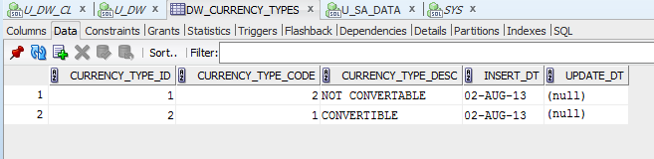

After updating the data in the source table and restart the package data is changed at stage-level.

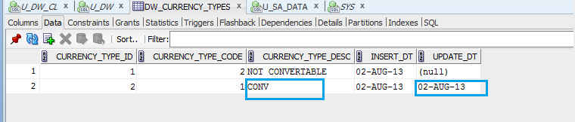

After repeated run the package the data in the table are unchanged. Test results are shown below:

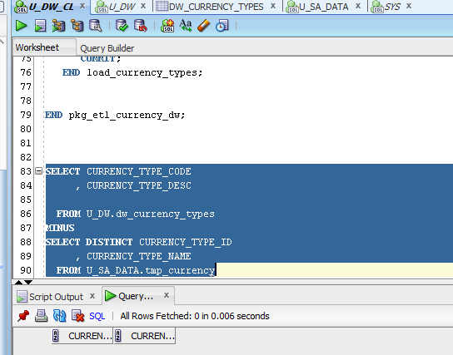

* + Use Variable Cursor and FORALL Bulk Insertion (One package)

CREATE OR REPLACE PACKAGE BODY pkg_etl_operations_dw

AS

*-- Load Data From Sources table to DataBase*

PROCEDURE load_operations

AS

TYPE cur IS REF CURSOR;

TYPE t_id IS TABLE OF NUMBER;

TYPE t_code IS TABLE OF NUMBER;

TYPE t_name IS TABLE OF VARCHAR2 ( 50 );

TYPE t_method_id IS TABLE OF NUMBER;

TYPE t_min IS TABLE OF NUMBER;

TYPE t_max IS TABLE OF NUMBER;

c1 cur;

blk_id t_id;

blk_code t_code;

blk_name t_name;

blk_min t_min;

blk_max t_max;

BEGIN

*--Insert Source data*

OPEN c1 FOR

SELECT DISTINCT sa_t.operation_id

, dw_t.operation_code

, sa_t.operation_name

, sa_t.operation_min_amount

, sa_t.operation_max_amount

FROM u_sa_data.tmp_operations sa_t

LEFT OUTER JOIN

u_dw.dw_operations dw_t

ON ( dw_t.operation_code = sa_t.operation_id );

LOOP

FETCH c1

BULK COLLECT INTO blk_id, blk_code, blk_name, blk_min, blk_max

LIMIT 1000;

FORALL i IN blk_code.FIRST .. blk_code.LAST

MERGE INTO u_dw.dw_operations o_s

USING (SELECT *

FROM u_sa_data.tmp_operations) cls

ON ( o_s.operation_code = cls.operation_id )

WHEN NOT MATCHED THEN

INSERT ( operation_id

, operation_code

, operation_name

, operation_max_amount

, operation_min_amount

, insert_dt )

VALUES ( seq_operations.NEXTVAL

, blk_id ( i )

, blk_name ( i )

, blk_max ( i )

, blk_min ( i )

, SYSDATE )

WHEN MATCHED THEN

UPDATE SET o_s.operation_name = cls.operation_name

, o_s.operation_max_amount = cls.operation_max_amount

, o_s.operation_min_amount = cls.operation_min_amount

, o_s.update_dt = SYSDATE

WHERE o_s.operation_name != cls.operation_name

OR o_s.operation_max_amount != cls.operation_max_amount

OR o_s.operation_min_amount != cls.operation_min_amount;

EXIT WHEN c1%NOTFOUND;

END LOOP;

CLOSE c1;

DELETE FROM u_dw.dw_operations

WHERE operation_id IN (SELECT t.operation_id

FROM u_dw.dw_operations t

WHERE t.ROWID > (SELECT MIN ( tt.ROWID )

FROM u_dw.dw_operations tt

WHERE t.operation_name = tt.operation_name));

*--Commit Result*

COMMIT;

END load_operations;

END pkg_etl_operations_dw;



After repeated run the package the data in the table are unchanged. Test results are shown below:



